At Comfort Home Care we take the safety of our service users very seriously and have provided the following guidance when handling hot water bottles. This area is also covered in the initial risk assessment when assessing an indivudals capablities, needs and preferences.

Reviewed 23/07/2019 Ryan Palmer (Registered Care Manager)

Legislation:
- Health and Safety at Work etc Act 1974 (HSWA), section 3.
- Management of Health and Safety at Work Regulations (MHSWR), regulation 3.
- Provision and Use of Work Equipment Regulations 1998 (PUWER).
Guidance:
- Check the safety standard, current standard is British Standard BS1970.
- When filling a hot water bottle, do not use boiling water and fill to a maximum of two-thirds capacity.
- Hold the bottle by the neck in an upright position and fill slowly to avoid hot water splashing back.
- Expel air from the bottle by lowering it carefully onto a flat surface until water appears at the opening. Screw the stopper sufficiently tight to ensure that there is no leakage. Finger tight should be adequate.
- Do not sit or lie on top of the hot water bottle.
- Use a cover or wrap the bottle when filling to avoid spills or use a hot water bottle filling stand.
- Do not fill using water from the domestic hot water system as this can prematurely degrade the hot water bottle.
- Prevent the bottle from contact with hot surfaces, oil or grease.
- When not in use drain completely and keep, with the stopper removed, in a cool, dry, dark place. Prevent exposure to sunlight. Do not place anything on top of the bottle.
- Check the bottle and stopper for wear and damage at regular intervals.
- Take care with elderly and children, warm the bed beforehand and remove the bottle before the person gets in.

WARNING:
HOT WATER BOTTLES CAN CAUSE BURNS. AVOID PROLONGED DIRECT CONTACT WITH THE SKIN.
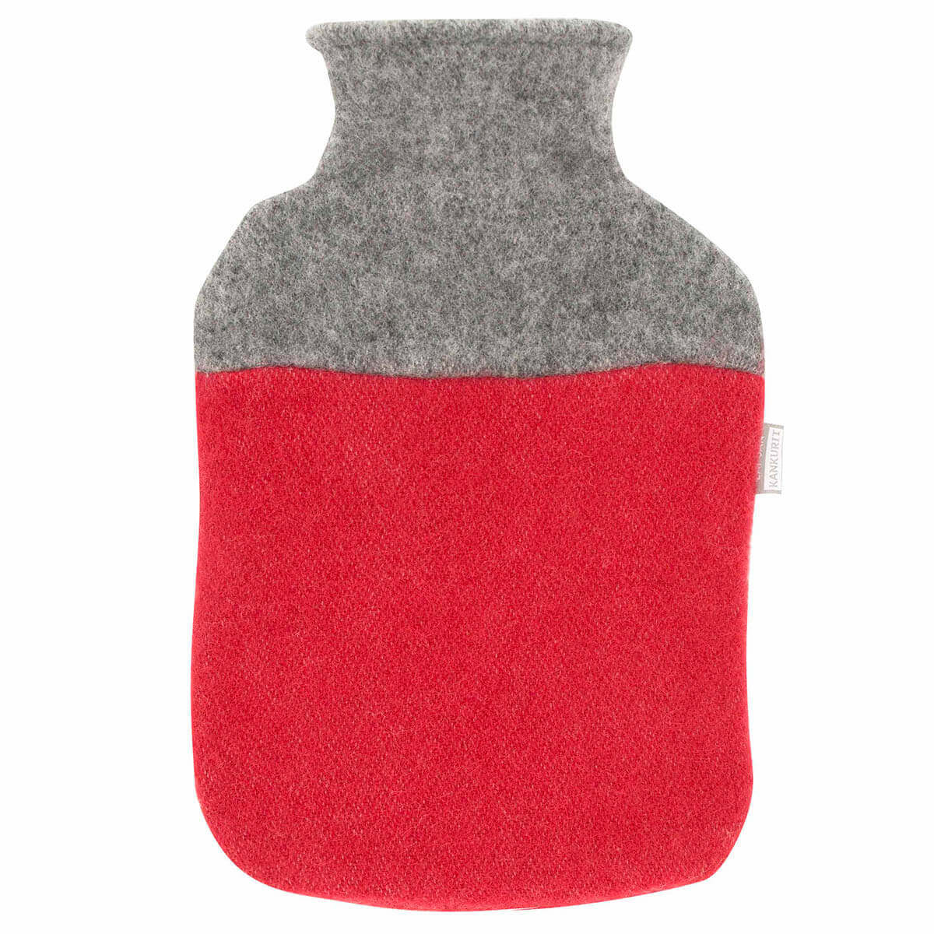

The information contained in this document has been explained to me and I agree to conform to the guidance.

Service User Name: Signature: Date:

